Mt Glorious Tips and Tricks – Coping with severe weather events

The forested mountain environment that we call home quickly becomes a very difficult place to keep power and communications infrastructure operating normally during severe weather events. History shows that we can expect outages of a few hours during a ‘normal’ storm season and outages of a day or more following severe events. Accepting this as normal means we can take steps that will lessen the interruption to our life when it does happen.
The information that follows is an accumulation of tips and tricks, mostly quite inexpensive, which may prove useful during an extended power outage. The aim is to give mountain residents every encouragement and confidence to become as self sufficient and resilient as possible when adverse conditions arrive next time.
- Water.
Not just for drinking but bathing and flushing too.

Most houses are supplied with tank water via a mains pressure pump system. When mains or generator power is not available, there are at least 4 other ways to easily access water in useful amounts:
- Gravity fed tap installed either on the bottom of your tank or in the water line toward your house. Collect water in clean buckets. (not useful for inground tanks)
- Syphon works if the top of your tank is above ground. Insert a length of tube eg garden hose, a short way under the water surface and run down to a lower level. Apply suction or use water in the tube to create a syphon. A nozzle on the outflow end will allow stopping and starting the flow without needing to create the syphon each time. The top end must stay in the water to do this.
- A Bucket or container sized to fit through the inlet of your tank is easy if you have safe access to the top of your tank.
- 12 volt pump run from your car cig lighter will easily pump large volumes, even a shower. Under $30 camp stores or ebay
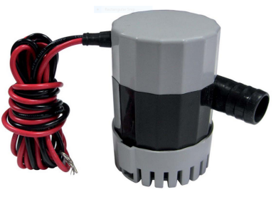

If your tanks are above the level of your house, some taps may still provide a useful flow even if the pump is not operating. Experiment.

If syphoning the old fashioned way is not for you, these are available at camping shops for less than $10.
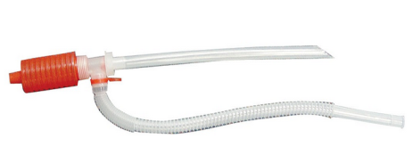

When a severe event is forecast, filling a few buckets or laundry tub beforehand is good preparation.
- Sewage.
Easy for an hour or 2 but not for a day or 2

Old style septic systems present no issues during extended power outages so long as waste can be effectively flushed by adding water to the cistern or direct to the bowl.

More modern Home Sewage Treatment Plants (HSTP) produce a high standard effluent but to do so may need power for aerators and definitely need power to pump out effluent to spray lines or trenches when it reaches a set level. The holding tank may have capacity for up to 24 hours with modest use.
The most critical issue for HSTPs during an extended power outage occurs when the treated effluent holding tank overflows, causing the 3 or 4 separate treatment stages to become one. This will almost certainly require a service call and probable pump out and restart. With a tanker of water, not much left of $1000.

There are 4 ways to delay or prevent this:

The first is to limit the volume going into the HSTP.

The second is to find alternative ways to empty the holding tank. If the lay of your property is downhill from the HSTP, use the aforementioned syphon hose or 12 volt pump to empty the tank (it’s usually clear water, in some cases lightly chlorinated). If you are uncertain how to do this, ask the service person on their next regular visit for a tour of your system! Also, this is one situation where the hose full of clear water would be a better syphon starter than suction.

The third way is to access a generator to pump out and gain a day or 2 respite.

The fourth way is to use someone else’s septic toilet.

- Hygiene

Normal bathing/showering may be restricted by lack of water or cold water. However, a satisfactory wash is quite possible with a kettle or saucepan of boiling water (see later options for this) mixed with a bucket of cold water. Add a cup for a deluxe shower experience!
Or buy a camp shower, pictured, add warm water, hang in your shower. <$20
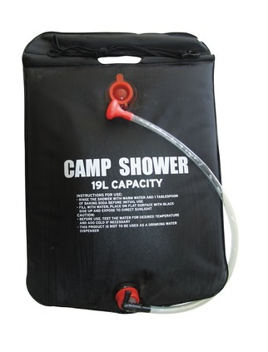

Under $50 will buy a 12 volt powered model with cig lighter lead off your car.

- Cooking and heating water
Homes with gas cylinders have no problems cooking or heating water. All electric households will need to use gas BBQs or keep a small camping stove for emergencies. Something like this is less than $30. 4 cans of gas cost $6. One of these cans will give about 45 minutes heat on full. A one pot recipe and dinner’s done.
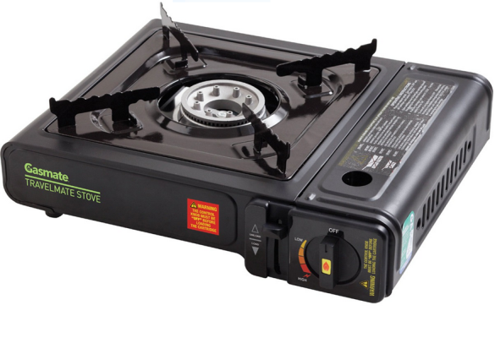

- Refrigeration
Life gets easier once you solve this one
Keeping food safely chilled or frozen long term needs power. It may be possible to get some ice, assuming access to Samford is available, which will buy some time.
For fridges, once power is off for 4 hours or more (and less with door openings while power is off) food safety experts advise extreme caution on the use of perishable food. A better guide is the use of a thermometer. If perishable food has been above 5°C for 4hours or more, it should be thrown out.
Remember, every door opening quickly increases the fridge temperature.
If the event has the appearance of a long power outage, it is best to consolidate stored items in one fridge to build as big a thermal mass in as little space as possible.
For freezers, 24 to 48 hours safe storage is possible so long as it is not opened. The longer storage time is most likely with a full freezer. Use a thermometer to confirm.
More info here on food safety during power outages

A generator is really the only solution to keep your fridges and freezers operational. See the Generator section for generator use and sizing.

During extended power outages eg around a day or more, generator power to run the large cold room and freezers is available at the Mt Glorious Community Hall courtesy of a permanently installed generator provided by Moreton Bay Regional Council for the benefit of the community. This is a fantastic community resource and part of the Disaster Management resources provided by MBRC.

Gas cooking facilities and hot water are also available at the hall.
Take action early to avoid food spoilage by transferring your fridge contents to the hall. Logistical arrangements for access will be publicised for each event. The community association has provided secure 24 hour access for residents via a digital lock.

- Power
You may have more than you think.
If you have a car, you also have a generator of sorts.
Many mobile phones and tablets also come with a car charging lead. Another solution to phone or tablet charging is devices such as these..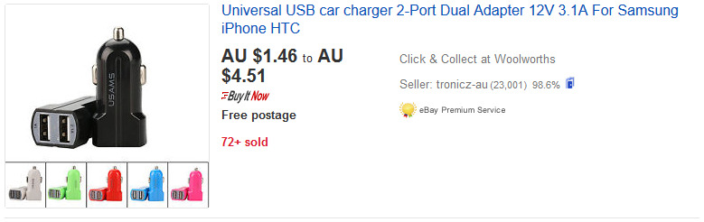
↑ Pictured is one of many ads for car phone chargers on ebay. Harvey Norman, Big W etc as well.

Your car can also provide limited 240 volt power from an inverter – a device which converts 12 volts DC to 240 Volts AC, like mains power. The best choice is one which outputs pure sine wave power (as opposed to modified sine wave) as these are the safest choice for the electronic power supplies in chargers, laptop computers and TVs. The one pictured costs $80 delivered on ebay and is rated at 300 watts continuous. This would power many phone, laptop and recyclable battery chargers (eg for emergency lights). An LED large screen TV would use no more than 150 watts so this size inverter could handle all of your communications and household lighting during an emergency. To use, simply clip onto the battery terminals on your car (too much power is needed for a cigarette lighter connection). If using for more than a few minutes, your car engine should be running.

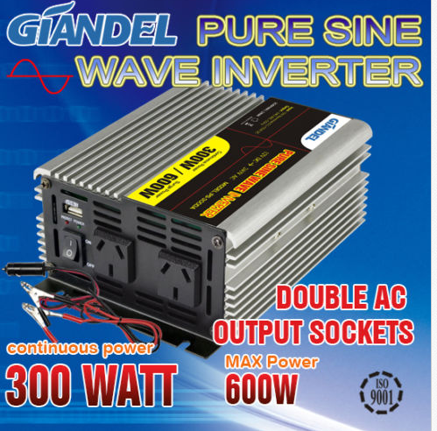

- Generators
Not perfect but the closest to normal power convenience
The purpose of a generator needs no explanation. Instead, the focus is on information to help make a good decision. If buying a generator you need to tally up the power requirement of the appliances you wish to operate. There are 2 elements to this: Operating power and starting power. Items like water pumps and fridge compressor motors briefly need between 4 & 6 times their operating power to get them running. Use the table as an indicator for the amount of power the generator must provide. A good source for further info can be found at
http://www.datastreamserver.com/manuals/Generator_Buying_Guide.pdf and
https://www.macfarlanegenerators.com.au/power-calculator.php

Appliance | Start kva | Run kva
Refrigerator 300 watts | 1.52 | .38
Water pump 750 watts/1hp | 3.6 | .9
Toaster 1250 watts | 1.56 | 1.56

For reasons not needed here, generators are most accurately rated in kilo volt amps (kva).
Bottom line, unqualified, non-expert advice: To start and operate a single water pump, and to separately start a domestic fridge, a 2Kva/1600 watt generator would be the absolute minimum size to purchase. A more comfortable choice would be 3.2 Kva/2500 watts or higher. Generators less than 5Kva would require careful load management in that the water pump and fridge may not start if both powered up simultaneously but both would comfortably run simultaneously if started sequentially.
Costs : No name, generic Chinese generators off Ebay start around $400 for 2 kva. Name brands such as Yamaha and Honda are around $2000 for similar capacity. Electric start is commonly available, even on cheaper Chinese models.

Sharing generators with friends and neighbours may be practical. A couple of hours run time, say, 3 times per day, will keep fridges in the safe zone indefinitely, as well as phones and lights charged.

Generator issues:
Dry storage, fuel availability and storage, start and run for a few minutes at least 3 monthly for reliable starting when you need it.
Unleaded petrol in tightly sealed full containers eg metal jerry cans stored in cool conditions will store for a maximum of 6 months. Products such as Sta-Bil fuel stabiliser will extend storage to 12 months (SuperCheap Auto, Bunnings, mower shops).
Ideally, generators should be stored for long periods with no fuel in the carburettor to prevent petrol evaporating and leaving ‘gummy’ residue in the carburettor which will prevent reliable starting (prevent by turning fuel valve off and/or run till empty).

- Around the house
The little things that can cause big problems
Damage from high winds, heavy rain and run off and even bush fire can be minimised by simple, routine maintenance around the house.
Keep vegetation that can contact the house in high winds trimmed well back.
Branches directly over the roof should be considered for removal.
Surface drains often block in the first few minutes of heavy runoff as uncleared leaf debris is mobilised. Keep them clear, at least before forecast events.
Know how to manually operate electric garage doors and automatic gates etc.
- Food
Most residents would have at least a few days of food supplies. Consider keeping, say, 5 days of non perishable staples eg powdered milk, flour, rice, canned foods to avoid the need for trips off the mountain. Assemble some simple, one pot recipes along with the required non perishable ingredients.
And don’t forget emergency rations for pets.

- Communications
Mobiles: Prior to forecast severe weather, ensure mobile phones are charged. Car charge leads as discussed earlier are very useful post event but it may not be advisable to go to your car during the storm to call for help.

Fixed line phones: Many properties at Mt Glorious are served by aerial cable (on the power poles) so are prone to damage from falling trees and branches. This type of damage will typically take several days to repair. This will also stop your internet access. Should this happen, you can arrange with your carrier to divert your fixed line calls to your mobile.
It is a good idea to have an old style non mains powered phone that you can use during power outages. Big W have a Uniden fixed line non mains powered phone for just $20.

When there is an extended power outage, the local Telstra exchange will operate for no more than 24 hours on its batteries. Fixed line and ADSL internet services will not be available until a generator is deployed at the exchange, typically less than a day based on past observation.

If comms are available, the Mountain Folk Facebook will be a great source of information.

If your fixed line and mobile service provider is the same as your internet service provider eg Telstra, it is worthwhile to ask them to extend your mobile data allowance while fixed line services are inoperative. Many residents have been given an additional 10gB on their mobile plans at no cost during past events. Increasingly, mobile phone plans have much greater data allowances than in the past.

Finally, a battery powered radio will provide emergency updates. ABC local radio 612 provides the official emergency services updates.

- Power reconnection issues
Following the extended local power outages resulting from ex cyclones Oswald and Debbie, there have been numerous examples of appliance and switch board damage apparently caused by reconnection power surges. Even surge arrestors installed on switch boards have been vaporised by the energy surge. The only practical way to prevent this is to isolate your property’s switchboard by operating the main power switch.
- Friends and neighbours

Make sure those around you are ok. If comms are suspect, a face to face check will be needed.

- Outside support and assistance

Confirm that you are registered with MoretonAlert via MBRC website for emergency sms updates. You should be familiar with the bushfire Early Warning System which you hear tested first Wednesday of every month. Current bushfire maps and info are available at https://www.ruralfire.qld.gov.au/

Prepare a list of your own emergency contacts starting with State Emergency Service 132500, PoliceLink 131444, Energex Power Outages 136262 and not forgetting 000 for all emergencies.

- First Aid competence
Don’t be the person who has no idea what to do when faced with a medical emergency or first aid issue. Keep a first aid kit, have a snake bite pressure bandage, buy a First Aid reference book, do the free CPR/Defibrillator course run regularly at the hall.

Futher tips: Have an idea that works for you? Let us know at mtgloriouscommunityassociation@outlook.com so we can include your idea here.

